In the Grocery Cart This Month
For SEPTEMBER: “Cleaning Products especially Laundry Detergent and Dish Washing Liquid. Also needed are Body Lotion, Shampoo, Conditioner, Body Wash, and Razors for men and women, Tampons, Adult Wipes, Handsoap, Hand Sanitizer. This will assist people through Park View Community Mission. Place donations in the grocery cart, located in the Commons. **NOTE: Please put all liquids in the box provided. Tape down all flip top bottles.
Read Ahead
Sept. 22, 2019~the Scriptures are 1 Timothy 2:1-7 & Psalm 79. The sermon text is Luke 16:1-13 and the message is “What Goes Around”.


Children and Their Safety are Important at Chestnut Hill UMC
We rejoice that as a church we are able to offer carefully planned, age appropriate care and activities for our children and youth.
Today, children ages 6 and above will stay in the sanctuary for worship.
The Nursery for infants up to age 6 is located in Classroom 101 (exit through the right side door at the front of the sanctuary, pass through “the Commons,” go through the double doors to the Education Building and follow the hallway to the
Nursery at the end of the hall on the left).

DIRECTORY OF CHESTNUT HILL UNITED METHODIST CHURCH
 | Sharma Lewis | Richmond Area Resident Bishop
 | Peter D. Weaver | Interim Bishop
 | Scott Davis | Lynchburg District Superintendent
 | Liz Ecklund | Minister
 | Vernie Barrow | Minister Emeritus
 | Monica Campbell | Administrative Assistant
 | Heather Wilson | Director of Music Ministry
 | Judy Martin | Bookkeeper
 | Judy Robertson | Lay Leader
 | Erin Ecklund | Nursery Supervisor


Chestnut Hill
United Methodist Church

Making disciples of Jesus Christ
for the transformation of the world.
You are welcome at Chestnut Hill UMC.

4660 Fort Avenue ~ Lynchburg, Virginia 24502
Church: 434-239-8423
Pastor’s Cell: 434-258-2934; Pastor’s Home: 434-319-5646
Email Pastor Liz: Pastorliz@aol.com
chestnuthillumc@comcast.net ~ on the web at chestnuthillumc.net
Find us on Facebook: Chestnut Hill United Methodist Church

Chestnut Hill United Methodist Church
10:30 a.m. ~ September 15, 2019 ~ Fourteenth Sunday after Pentecost
Our ministry vision for the Virginia Annual Conference is “to be disciples of Jesus Christ who are lifelong learners, who influence others to serve.”
Welcome! Join us in worshiping God!
Welcome and Ministry Announcements
Welcome in the name of Christ our Lord. Please register your attendance,
printing your name, address, phone, and email, when the pew pad is passed to you.
Thank you for silencing cell phones as we gather to worship God.
Invocation
Prelude “My Faith Looks Up To Thee” arr. Ellson
*Call to Worship
Fools and sages come to the throne of grace.
All are welcome here.
Those who are lost and hoping to be found come find a home at the seat of glory.
All are welcome here.
Sinners and saints come to the place of new beginnings.
All are welcome here.
*Singing Our Faith # 98 “To God Be the Glory”
Morning Prayer
Almighty Creator God, You are indeed our Good Shepherd, and we are so blessed to be a part of Your flock. Give us the loving heart to seek others who are lost and bring them to You. In Christ we pray. Amen
Prayer of Confession
Words of Assurance
With overflowing grace, Christ Jesus came to save us. With steadfast love, the King of kings leads us into eternal life.
Choral Anthem “Lord, I Lift My Hands To You” arr. Althouse

Prayer for Illumination Ann Robbins
Lord, open our hearts and minds by the power of your Holy Spirit, that, as the Scriptures are read and your Word proclaimed, we may hear with joy what you say to us today. Amen.
Gospel Lesson Luke 15:1-2, 11-32 (CEB) Ann Robbins
The Word of God for the people of God.
Thanks be to God.
*Singing Our Faith # 378 “Amazing Grace”
The Good News “Facebook Testaments?”
The Giving of God’s Tithes and Our Gifts
Prayer of Thanksgiving
Offertory “Create in Me A Clean Heart” arr. Hayes
*Doxology # 95 Praise God from whom all blessings flow; praise him, all
Creatures here below; praise him above, ye heavenly host; praise Father, Son, and Holy Ghost. Amen.
The Prayers of the People
The Lord’s Prayer
Our Father, who art in heaven, hallowed be thy name. Thy kingdom come,
Thy will be done on earth as it is in heaven. Give us this day our daily bread and forgive us our trespasses, as we forgive those who trespass against us. And lead us not into temptation, but deliver us from evil. For thine is the kingdom, and the power, and the glory, forever. Amen.
*Singing Our Faith # 103 “Immortal, Invisible, God Only Wise”
*Blessing and Dismissal
*Postlude
Scatter to Serve God & Neighbor
Welcome to all! We gather to praise God for the innumerable blessings given to us and to grow deeper in the Spirit. Joyfully, let us lift our hearts to God.

**This Week’s Calendar**

Monday, 9/16 | 10:30 a.m. | Missions Committee
 |  | Deadline for October newsletter articles.
Tuesday, 9/17 | 9:00 a.m. | Prayer Group
 | 10:00 a.m. | Homeschool First
 | 1:00 p.m. | Homeschool First Games
Thursday, 9/19 | 6:00 p.m. | Handbells
 | 6:45 p.m. | Choir
Friday, 9/20 |  | Church Office Closed
 | 9:00 a.m. | Homeschool First
** Looking Ahead on the Calendar **

Wednesday, 9/25 | 11:00 a.m. | Top of the Hill  Chesley R. Vohden, Director Of Church Relations for Society Of St. Andrew, will be our speaker. She has served in many capacities such as The Salvation Army and other service organizations. Before coming to SOSA she actually dug potatoes with the Girl Scouts for The Society Of St. Andrew. Bring a sandwich. Dessert and drinks provided.
Sunday, 9/29 | 9:15 a.m. | Multigenerational Sunday School  Sunday school classes will meet together in the fellowship hall for a light breakfast and guided discussion.


The rose placed in the sanctuary is in honor of the birth of Lydia Brooks Vessey, born to Andrew & Laura White Vessey on September 10, 2019. The proud grandparents are John & Jane White. Congratualtions to
all!!
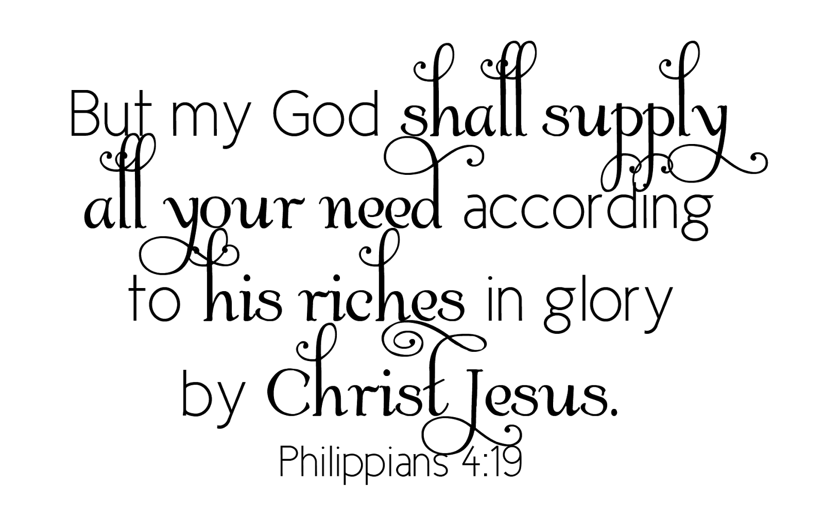
**This Week’s Calendar**

Monday, 9/16 | 10:30 a.m. | Missions Committee
 |  | Deadline for October newsletter articles.
Tuesday, 9/17 | 9:00 a.m. | Prayer Group
 | 10:00 a.m. | Homeschool First
 | 1:00 p.m. | Homeschool First Games
Thursday, 9/19 | 6:00 p.m. | Handbells
 | 6:45 p.m. | Choir
Friday, 9/20 |  | Church Office Closed
 | 9:00 a.m. | Homeschool First
** Looking Ahead on the Calendar **

Wednesday, 9/25 | 11:00 a.m. | Top of the Hill  Chesley R. Vohden, Director Of Church Relations for Society Of St. Andrew, will be our speaker. She has served in many capacities such as The Salvation Army and other service organizations. Before coming to SOSA she actually dug potatoes with the Girl Scouts for The Society Of St. Andrew. Bring a sandwich. Dessert and drinks provided.
Sunday, 9/29 | 9:15 a.m. | Multigenerational Sunday School  Sunday school classes will meet together in the fellowship hall for a light breakfast and guided discussion.

The rose placed in the sanctuary is in honor of the birth of Lydia Brooks Vessey, born to Andrew & Laura White Vessey on September 10, 2019. The proud grandparents are John & Jane White. Congratualtions to
all!!

